**Experiment 14**

**Dhruv Singhal || 500075346 || R177219074 || AIML || Sem5**

**DBSCAN Implementation**

**Importing Required Libraries**

In

[1]:

**from**

sklearn

.

cluster

**import**

DBSCAN

**import**

pandas

**as**

pd

**import**

matplotlib

.

pyplot

**as**

plt

**import**

warnings

**from**

sklearn

.

preprocessing

**import**

StandardScaler

warnings

.

filterwarnings

(

'ignore'

)

**Data**

for this experiment we have use make_blobs datsets which are already in sklearn.datasets

sklearn.datasets.make_blobs(n_samples=100, n_features=2, *, centers=None, cluster_std=1.0, center_box=(- 10.0, 10.0), shuffle=True, random_state=None, return_centers=False) Generate isotropic Gaussian blobs for clustering.

In

[2]:

In

[3]:

In

[4]:

Out[4]:

,

2)

(1000

**from**

sklearn

.

datasets

**import**

make_blobs

X

,

y

**=**

make_blobs

(

n_samples

**=**

1000

,

n_features

**=**

2

,

centers

**=**

[[

0.5

,

2

,

[

]

**-**

1

,

**-**

1

]

,

[

1.5

,

**-**

1

]]

,

cluster_std

**=**

0.5

,

center_box

**=**

(

**-**

10.0

,

10.0

)

,

shuffle

**=**

**True**

,

random_state

**=**

42

)

X

.

shape

In [5]: y.shape

Out[5]: (1000,)

**Data Preprocessing and Visualization**

In

[6]:

Out[6]:

149f3388>

<

matplotlib.collections.PathCollection at 0x1bc

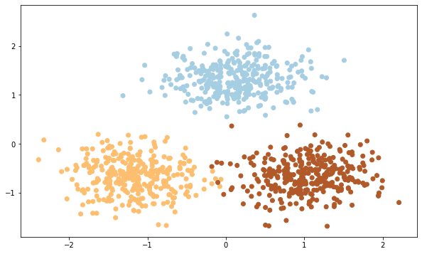

X

**=**

StandardScaler

().

fit_transform

(

X

)

plt

.

figure

(

figsize

**=**

(

10

,

6

))

plt

.

scatter

(

X

,

[:

0

]

,

X

[:

,

1

]

,

c

**=**

y

,

cmap

**=**

'Paired'

)

**Model Building**

In

[7]:

Out[7]:

matplotlib.collections.PathCollection at 0x1bc16dcd

608>

<

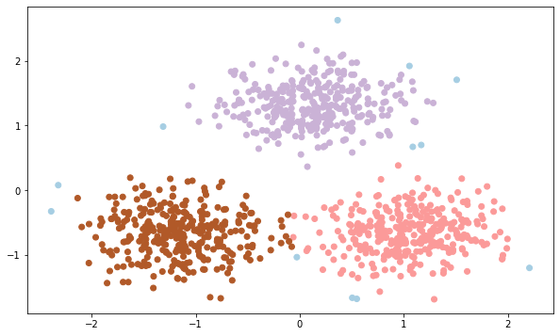

db

**=**

DBSCAN

(

eps

**=**

0.45

,

min_samples

**=**

50

)

db

.

fit

(

X

)

y_pred

**=**

db

.

fit_predict

(

X

)

plt

.

figure

(

figsize

**=**

(

10

,

6

))

plt

.

scatter

(

X

[:

,

0

]

,

X

[:

,

1

]

,

c

**=**

y_pred

,

cmap

**=**

'Paired'

)

In [ ]: